# CS 255 System Design Document

## UML Diagrams

### UML Use Case Diagram

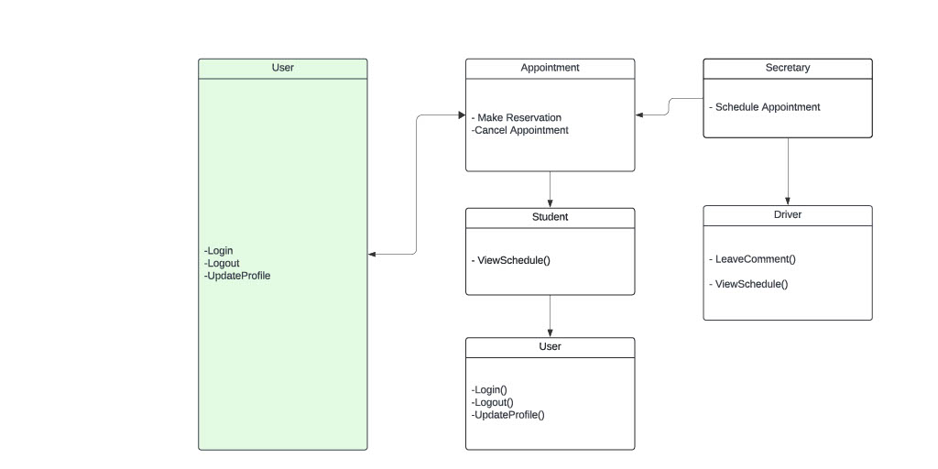

### UML Activity Diagrams

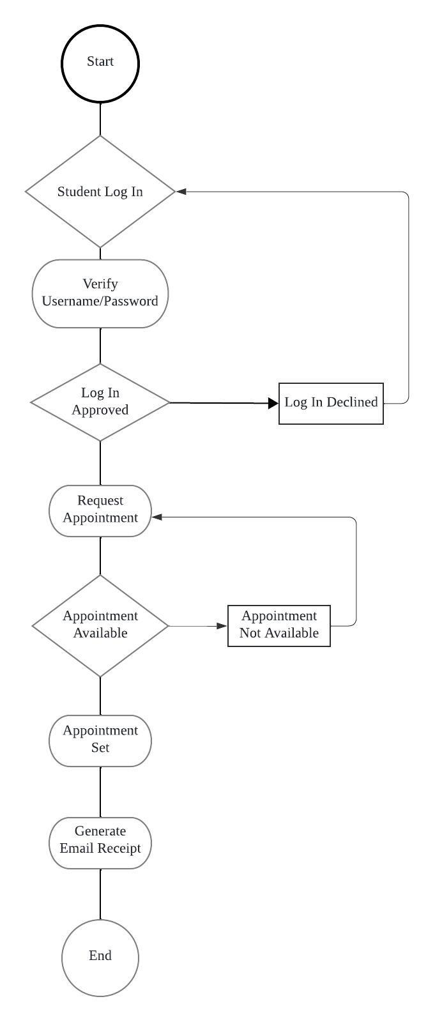

### UML Sequence Diagram

[You were asked to create a sequence diagram based on **one** of the use cases you chose. Please insert your sequence diagram here. Check to make sure that you included appropriate components and symbols and that your design meets the client’s needs.]

### UML Class Diagram

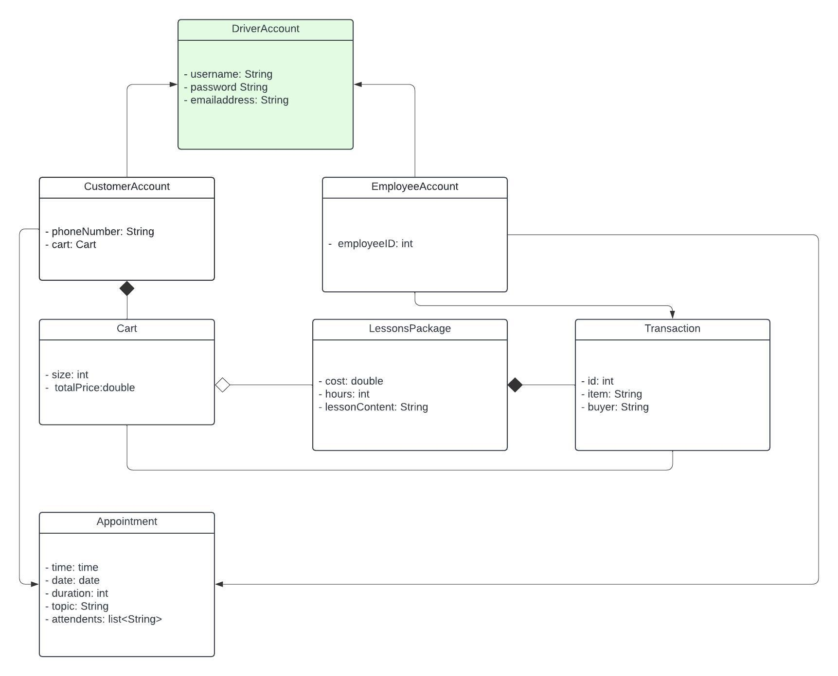

## Technical Requirements

**Hardware Requirements:**

Servers: Reliable servers to host the web application, database, and possibly other services. These could be physical servers or virtual instances in the cloud.

Workstations: For administrative staff, including the big boss (Liam), IT officer (Ian), and the secretary, to manage the system and interact with customers.

Mobile Devices: Compatibility with mobile devices for customers and staff to access the system on the go.

**Software Requirements:**

Web Application Platform: A robust platform for developing the web interface. This could include technologies like HTML, CSS, JavaScript for the frontend, and a backend framework such as Django, Ruby on Rails, or Node.js.

Database Management System (DBMS): A database system like MySQL, PostgreSQL, or MongoDB to store and manage customer data, reservation details, lesson schedules, and package information.

**Cloud Services:**

If opting for cloud hosting, services like AWS, Google Cloud, or Azure to host the web application, database, and other necessary services.

Security Software: For protecting data and ensuring secure access to the system, including firewalls, SSL certificates, and possibly a dedicated security management tool.

**Infrastructure Requirements:**

Internet Connection: High-speed and reliable internet connection for online access to the system by customers and staff.

Cloud Infrastructure: If using cloud services, an appropriate subscription to cloud infrastructure services for hosting the application, database, and other components.

Backup and Recovery Solutions: Mechanisms for data backup and recovery to prevent data loss and ensure system continuity.

**Compliance and Integration:**

DMV Integration: A mechanism to integrate with DMV systems for up-to-date tests, policies, and sample questions, which may require specific compliance standards to be met.

Payment Processing: Integration with payment gateways for processing customer payments securely.